**CIS 8391 – Big Data Analytics Experience**

**Final Project Report**

**December 10, 2021**



**Audio and Video Analysis**

**Team: *Matrix***

**Members:**

***Ayush Shah***

***Chandana Narayanan***

***Snithin Soodini***

***Vinitha Ramani***

**Contents**

Business Problem ………………………………………………………………………… 3

Value Creation …………………………………………………………………………… 4

Road map ………………………………………………………………………………… 5

Data set and features ……………………………………………………………………... 6

Architecture Diagram ……………………………………………………………………. 7

ELT…..…………………………………………………………………………………. 11

ML Approach …………………………………………………………………………… 15

Challenges ……………………………………………………………………………….. 22

Future Work ……………………………………………………………………………… 23

Learnings and takeaways ………………………………………………………………… 24

References……………………………………………………………………………….. 25

**Business Problem**

*SBIR Intern* – Sirs, the submissions for this year are in.

*SBIR Judge1* – How many?

*SBIR Intern* – 450

*SBIR Judge1* – Alright. Judge2, you review 200, I will do 200 and we will give the rest for review to Judge3

*SBIR Judge2* - Sounds good!

Does it really? This is just one scenario where an entity needs to review submissions/content which can be videos or audio. Other use cases can include an online video platform for the people where the videos need to abide by community guidelines, or analyzing movies to get insights like screen time, sentiment, and tone of the movie. What if there is a system in place that can load, transform, and present key insights from videos and audio without manually going through each one of them? Of course, the insights will be missing the instincts and decision making of a human being. There is a middle ground though. When the files are too large and many, filtering out them based on solid set criteria can save a lot of man hours while presenting with facts like video quality, framerate, number of frames, audio quality, frequent words, optical gradient flow of light, etc. most which the human eyes and ears cannot figure out.

The goal of Matrix is to come up with a similar system that will be performing video analysis on the frames of SBIR’s submission videos and NLP on the text that will be converted from audio which in turn will be extracted from the videos. Once this model is in place, we presume that any entity with their own set of criteria will be able to filter out videos and audio for further use. The aim of this project is to extract sentiments from the audio, understand what kind of images are frequent in frames (employees, aerial views, animations man vs woman ratio, etc.) and what is the key terminology used that is common among the winners of this grant. This will enable the judges above to not go through each submission. Thus, if they want videos which have only a certain sentiment throughout, or videos which show a certain minimum participation of women, the system will filter those out and present for consideration.

**Value Creation**

This system will help achieve the following:

* A comprehensive model that will do everything from extracting the videos from source, converting to audio and text to analyzing and presenting key insights from them.
* Reduction in man hours to go through videos and audio for analysis.
* Automatic filtering of videos and audio based on *custom* criteria (video and sound quality, sentiments, duration, gradient flow, etc.)
* Detecting content that does not follow *custom* guidelines (graphic images, cuss words, negative sentiments, etc.)

**Use Cases**

The main use case we are focusing on here is to build and use the model to evaluate videos that are submitted for a competition. There are other use cases where this model is of relevance.

These include:

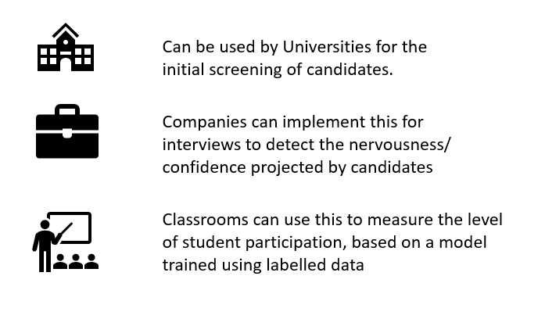

*Fig: Other use cases*

**Road Map**

The following steps will be taken to achieve the goal of the project:

Data Sourcing (Extraction) - The data which includes primarily of the SBA (Small Business Administration) winners' videos will be taken from the website. Using some of the key words the non-winner videos will be collected.

Data Storage (Loading) - The videos that are sourced will be either loaded into S3 bucket or placed in the local storage depending on the overall size of the outputs. However, considering the likeliness of a huge volume, S3 bucket would be considered.

Data Processing (Transformations) - Databricks would be used to access all the videos for transformation. The videos that are collected would be transformed into audio from which the text would be extracted. The images from every frame of the video will also be generated and used for the analysis.

Data Analysis: Various machine learning methods like NLP, emotions detection, image processing etc. would be applied to gauge the commonalities that the winner's video has as compared to the other videos.

Data Visualization: Since we deal with images, the scope of visualization would be limited. However, visuals like word cloud will be used to display the results of the text analysis

Business Solution: The final solution will be an algorithm / logic to identify a set of most likely winners in the upcoming funding competitions which can be further analyzed by humans to hand pick the winners

**Data Description**

We have chosen this project to mainly familiarize with the various multimedia datatypes. We interacted with audio, video/image as well as text and was able to heuristically learn the complexities of processing each of these.

There was a total of **how many** videos which were converted to images, audios, and texts for further analysis. This section gives the metadata of each section:

Video Analysis Metadata:

Audio Analysis Metadata:

Text Analysis Metadata:

**Architecture Diagram**

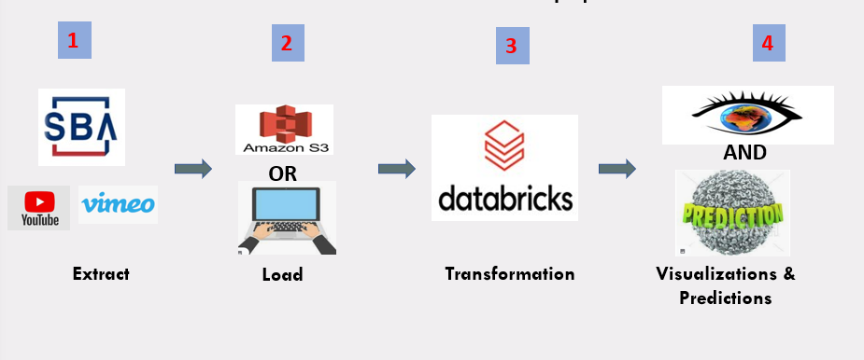

*Fig: Architecture Overview*

As depicted in the architecture overview diagram, there are 4 major components for the implementation of this project.

The first part is data acquisition. For this, most videos are sourced from the official website of SBA where the video links of pitches by the winners are posted. HTML scraping methodologies are used to extract the YouTube and Vimeo video links. For the next set of videos which mostly includes the startup pitches of other contestants that did not win the grant, we are relying on YouTube APIs (Application Programing Interface) to gather the links of videos based on relevant videos such as 'SBA Growth Accelerator Competition'.

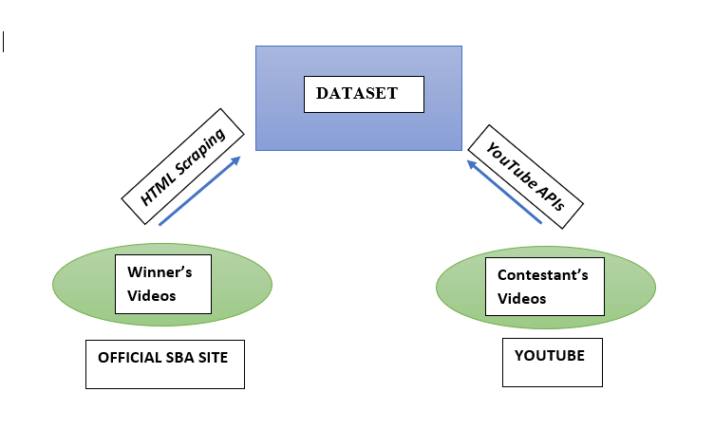

*Fig: Structure of Dataset*

The second part deals with storage. The entire dataset which comprises of videos of winners as well as that of losers, once downloaded, needs to be stored securely to be later accessed for necessary transformations and ML algorithms. We have 2 options for this:

1. **Amazon S3** - S3 stands for Simple Storage Service and it is a service offered by Amazon Web Services that provides object storage through a web service interface. It is an object storage service that offers industry-leading scalability, data availability, security, and performance. Customers of all sizes and industries can use Amazon S3 to store and protect any amount of data for a range of use cases, such as data lakes, websites, mobile applications, backup and restore, archive, enterprise applications, IoT (Internet of Things) devices, and big data analytics. To store your data in Amazon S3, you first create a bucket and specify a bucket name and AWS (Amazon Web Services) Region. Then, you upload your data to that bucket as objects in Amazon S3. Each object has a key (or key name), which is the unique identifier for the object within the bucket. Buckets and the objects in them are private and can be accessed only if you explicitly grant access permissions, thereby ensuring that our dataset is stored securely.

Major features of Amazon S3:

* Amazon S3 allows you to migrate, store, manage, and secure all structured and unstructured data at unlimited scale, breaking down data silos.
* Amazon S3 is a service for storing substantial amounts of unstructured object data, such as text or binary data.

In order to access AWS S3 buckets, we need to mount the buckets using DBFS or directly using APIs. We can mount an S3 bucket through Databricks File System (DBFS). The mount is a pointer to an S3 location, so the data is never synchronized locally. Once a mount point is created through a cluster, users of that cluster can immediately access the mount point. You can manage authentication and authorization for an S3 bucket using an AWS instance profile. The type of access to the objects in the bucket is determined by the permissions granted to the instance profile. Once an S3 bucket is mounted to DBFS you can access S3 objects using local file paths.

2. **Local storage** - Each of the SBA pitch video is about 2 minutes long and comes approximately 40 mb in size. So, storing the entire dataset in the local machine is also a feasible option. Local Storage usually refers to anything that is “on-premises”. In this approach we have the following benefits:

* Speed is one of the main advantages to local storage.
* Storing data on external hard drives is faster than uploading to the cloud.
* We will also have full control of backups, which means better control of who accesses your data.

The third segment deals with data transformation. Since we are processing and transforming massive quantities of data and exploring the data through machine learning models, the most optimum solution is to use Databricks.

Databricks is built on top of Spark and adds exceptionally reliable and performant data pipelines. It offers a distributed cloud computing environment, and has provisions to code in Spark's native R, Scala, Python or SQL interface. Other main advantages offered by Databricks includes:

* Reliable and performant Data Lakes.
* Higher productivity and collaboration - Deploying work from Notebooks into production can be done instantly by just tweaking the data sources and output directories.
* Integrates easily with the whole Microsoft stack - Azure Databricks uses the Azure Active Directory (AAD) security framework. Using AAD allows easy integration with the entire Azure stack including Data Lake Storage (as a data source or an output), Data Warehouse, Blob storage, and Azure Event Hub. However, in this project we will not benefit much from this feature.
* Extensive list of data sources - Aside from those Azure-based sources mentioned, Databricks easily connects to sources including on premise SQL servers, CSVs, and JSONs. Other data sources include MongoDB, Avro files, and Couchbase.
* Suitable for small jobs too - While Azure Databricks is ideal for massive jobs, it can also be used for smaller scale jobs and development/ testing work. This allows Databricks to be used as a one-stop shop for all analytics work.
* Extensive documentation and support available - While Databricks is a more recent addition to Azure, it has existed for many years. Extensive documentation and support are available for all aspects of Databricks, including the programming languages needed.

The last portion portrays the output in easily comprehensible formats. The output essentially consists of two parts:

1. Predictions: By using a subset of all the video data for both winning and losing groups as training dataset, the model is trained to predict the outcome of a pitch based on the video data that is supplied to the model. We are using a subset of the total data as test data to validate the model as well.
2. Visualizations: All the observations that we can gather by studying the winner's video as well as by comparison with the loser's video should be projected in an easy-to-understand fashion. We will be relying on NLP to analyze the text along with audio analysis, video sampling and image processing, and other object detection algorithms to arrive at conclusions.



*Fig: A sample output of word cloud.*

**ELT**

ELT, standing for Extract, Load and Transform, is the process involved in collecting data from different sources, loading the data and transforming it into a usable resource to fix the business problems.

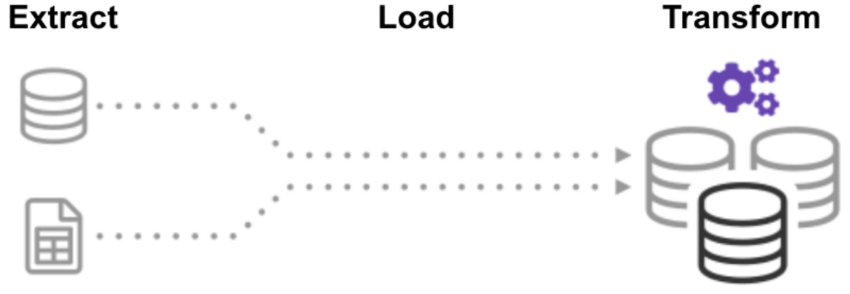

**Extraction**

The most crucial aspect of ETL represents Extraction. Since this stage is responsible and linked to the success of subsequent processes. In most of the projects, data is collected and combined from different sources. Another vital aspect of Extraction involves data validation to ensure whether the data collected from the sources have the expected values. During a project, data is sourced from multiple sources, converted into a simplified format for further analysis, and stored in data warehouses.

The extraction for winners and losers are handled separately.

1. Data extraction of winner's videos:

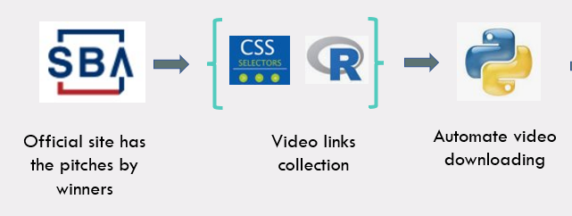

*Fig: Data Extraction for winners*

Data extraction begins from scraping the SBIR website, downloading the video submissions of hundreds of participants in our project. We have used CSS selectors and R programming to generate links to download the videos from variable xpaths. Our database has videos from 2 primary sources, i.e., YouTube and Vimeo. Links to the videos are stored in a string and then independent downloading packages for each source to download the videos. We have downloaded the best video quality during the Extraction to ensure proper data transformation and stored the data with chronological naming.

1. Data extraction of loser's videos:

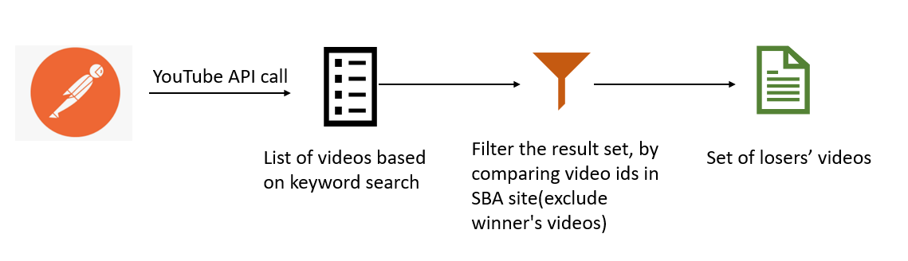

*Fig: Data Extraction of other candidates from YouTube*

Postman is an HTTP client that tests HTTP requests along with a user interface through which we obtain respective responses. Google has provided APIs that interact with YouTube. We will be using an API call that provides the YouTube video IDs as response based on the list of keywords sent in the HTTP request.

The format for this request is as follows:

[https://www.googleapis.com/youtube/v3/search?q={List of Keywords}&type=video&key={Google](https://www.googleapis.com/youtube/v3/search?q=SBA+Growth+Accelerator+Competition&type=video&key=%7bGoogle) API Key}

**Adding extra content**

Similarly, we need to collect all the videos that are hosted in Vimeo, but not published in the official SBA site. For this, we created an app in the Vimeo Developer console and with the secret key and client ID obtained made REST API calls for various relevant keyword combinations. The response was in JSON format, which contained the video links along with other metadata.

*Fig: Data Extraction of other candidates from Vimeo*

After the extraction was done, we had a total of 1202 videos in which 218 was from Vimeo and 984 from YouTube.

Once all the set of videos are obtained, we compare the video ids to that of the winners list which we obtained from official SBA site. These videos along with other search results that are not relevant will be excluded to give the final dataset of loser’s videos. The video filtering will be carried out mainly based on 4 factors:

* Exclusion of SBA winners.
* Removal of duplicate IDs
* Location only US
* Duration based filtering (1 min – 2:20 min)

After all these, we obtained a total of 145 loser’s videos

**-------**

Once all the set of videos are obtained, we will compare the video ids to that of the winners list which we obtained from official SBA site. These videos along with other search results that are not relevant will be excluded to give the final dataset of losers videos.

**Storage**

The videos once downloaded in the required quality and formats can be either uploaded to the cloud which is to upload in Amazon S3 buckets or can be stored in the local machine as well.

We are comparing the advantages of each of these to decide the most feasible option for our project.

|  |  |
| --- | --- |
| **Advantages of Cloud Storages (Amazon S3)** | **Advantages of Local Storage** |
| High scalability | High Speed as there is no internet bandwidth dependency |
| High availability and disaster recovery capabilities | Constant connectivity to access your data |
| Highly secure during a file transfer session, i.e., when files are being uploaded to your server, files are protected via data-in-motion encryption technologies like SSL/TLS (in the case of FTPS or HTTPS) or SSH (in the case of SFTP). | You have complete control over how the data is stored, who has access, and information security protocols |

**Transformation**

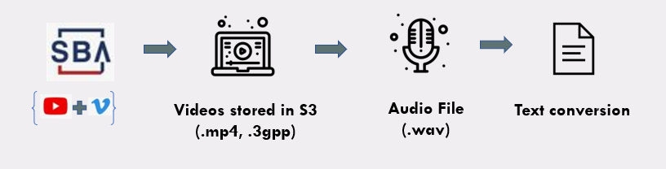

*Fig: Data Transformation Overview*

The extracted data is being broken down into 2 significant components, images and audio extraction. After extracting the data from web scraping and downloading the relevant videos, the data in the video is transformed into a set of images and audio transcripts. The data set contains more than 250 videos, and each video is comprised of 2 min length, divided further into around 80-100 frames with a time interval depending on the frame rate of each video. In total, there will be an image database of more than 25,000 with different image quality, in-built text, and human emotions, etc. After considering all these factors and linking them with the audio transcript, we have created a realistic dataset for a holistic analysis.

**ML Techniques Used**

For the analysis there will be 2 main components:

*Image recognition* - To extract the image frames from the videos and using OpenCV and Sci-kit Image libraries to understand what kind of images are persistent throughout the submission files, getting the male to female ratio of people featuring in the videos, detecting buildings, people or animations present in the videos, etc.

*Audio and Text Analysis –* To extract the audio from the videos and using SpeechRecognition and CNN (Convolutional Neural Network) model to analyze metrics like the general tone of the video, sentiments of speakers and frequent words used.

1. **Image Recognition**

Analysis of the frames within the video will be performed post extracting the frames from the videos. To do this the following steps were taken:

Step 0: Import OpenCV

Step 1: Get *framerate* of the video using cap (5)

Step 2: Parse through every *frame* using cap (1)

Step 3: If the *framerate* divides the *frame number,* write the *frame* asa ‘.jpg’ file to the video’s folder.

All the usable frames of the video are now ready to use.

Following is the code snippet for the extracting frames: 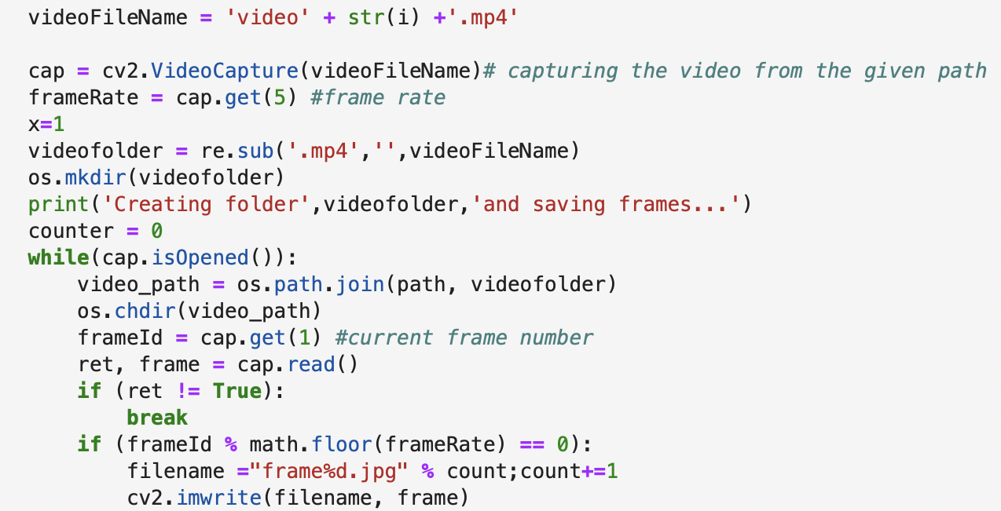

Following screenshot holds all the frames extracted from a video named *‘video1.mp4’:*

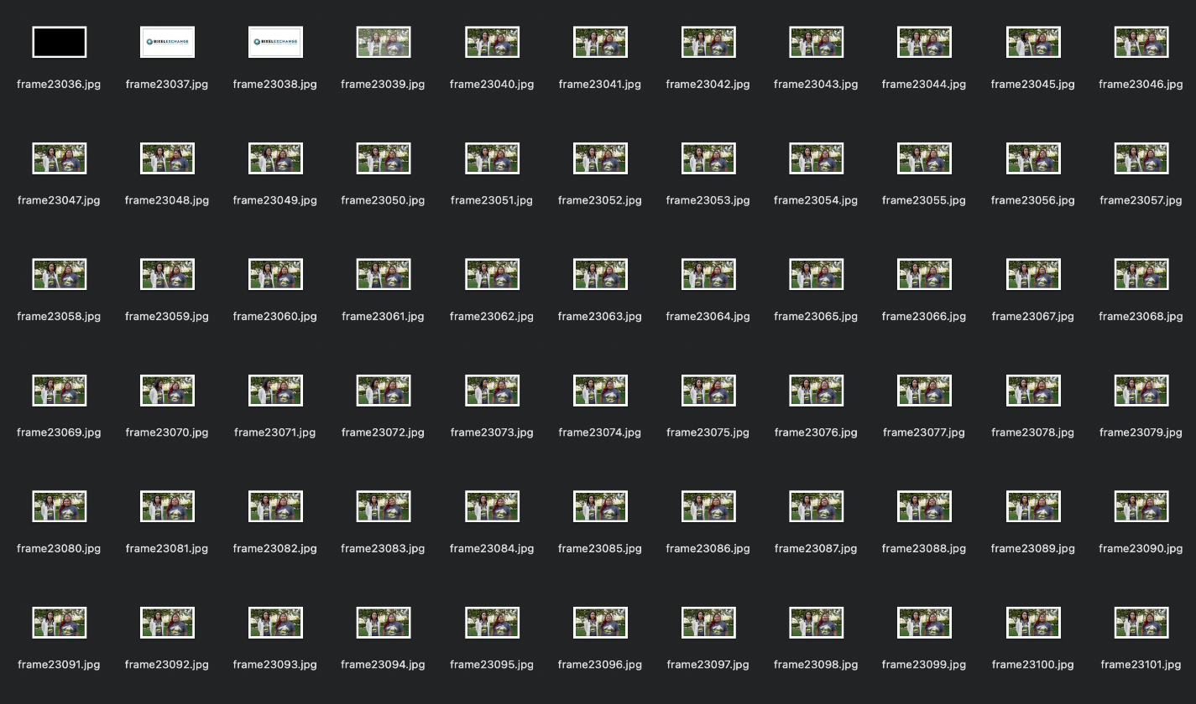

**Sci-kit Image:**

* Using Sci-kit Image, active contours will be used to create object boundaries (people, buildings, etc.) and the respective objects will be counted per video.
* This will enable the system to derive the ratios of actively used objects within submissions that can be further used to satisfy different criteria. For example, every video should have a certain number of women present or every video should have the infrastructure of the company depicted.

1. **Audio Analysis**

We are analyzing the audio present in the format in two different manners:

1. By converting the audio to text and employing text analysis
2. Converting the audio to images and performing CNN modelling

The first method is explained in detail in the text analysis part. In this section we will talk about the digital representation of sound.

Detecting sentiments through audio is one of the primary interests in such a competition to understand the confidence and tone of the participants. Listening to all the pitches and understanding the tone of the participants could be a strenuous task considering the volume of registrations. Even in the event of limited registrations, the interpretation of the tone and emotions conveyed through the pitches will be interpreted in different ways by different people leading to a difference of opinion. We often think of audio data as just data we interpret and process through our auditory system, but that doesn’t have to be the only way that we analyze and interpret audio signals. So, what is the alternative? Converting the audio files into a picture such that we can visually see and analyze the pitches than just hearing it. The visuals can be in the form of a waveform plot or a spectrogram.

Spectrogram is more helpful than a wave form since it reveals the hidden insights of an audio than the waveform. It is a representation of frequency over time in the form of a 2D graph and the third dimension of amplitude represented by color. It denotes the intensity of the signal at a frequency of time and helps in distinguishing between noise and the audio that will be of interest to interpret. All the audio that was generated from the video in the form of wav file was converted into respective spectrograms such that one spectrogram represents one audio file.

In physics, sound is a vibration that propagates as an acoustic wave, through a transmission medium such as a gas, liquid or solid. The sound signals often repeat at regular intervals so that each wave has the same shape. The height shows the intensity of the sound and is known as the amplitude. Here we are more interested in representing the audio digitally. Audio sampling is the process of transforming a musical source into a digital file. Sampling is a method of converting an analogue audio signal into a digital signal. While sampling a sound wave, the computer takes measurements of this sound wave at a regular interval called sampling interval.

Each of the intervals here is a sample. To get a context, a common sampling rate is about 44,100 samples per second. That means that a 10-second music clip would have 441,000 samples.

Although this is a representation of sound, here we consider spectrums that can give more details about sound waves.

**Spectrograms**

A spectrogram is a visual way of representing the signal strength, or “loudness”, of a signal over time at various frequencies present in a particular waveform. Not only can one see whether there is more or less energy at, for example, 2 Hz vs 10 Hz, but one can also see how energy levels vary over time.

Spectrograms are basically two-dimensional graphs, with a third dimension represented by colors. Time runs from left (oldest) to right (youngest) along the horizontal axis. The vertical axis represents frequency, which can also be thought of as pitch or tone, with the lowest frequencies at the bottom and the highest frequencies at the top. The amplitude (or energy or “loudness”) of a particular frequency at a particular time is represented by the third dimension, color, with dark blues corresponding to low amplitudes and brighter colors up through red corresponding to progressively stronger (or louder) amplitudes. To generate a spectrogram, a time-domain signal is divided into shorter segments of equal length. Then, the fast Fourier transform (FFT) is applied to each segment. The spectrogram is a plot of the spectrum on each segment. The Frame Count parameter determines the number of FFTs used to create the spectrogram and, as a result, the amount of the overall time signal that is split into independent FFTs.

*Fig: A sample spectrogram*

We converted the losers and winners audio to spectrograms by using the package TuneR in R. We noticed the pattern distinctions in some of the videos that clearly show high energy (bright colors) spread across time in winners video compared to that of losers.  
  
*Fig: Winner and Loser spectrograms*

Once all the winners and losers' videos were converted into spectrograms they were used as image inputs to perform CNN analysis. A Convolutional Neural Network (CNN) learns to recognize patterns across spacial data. It has been proven to be successful in identifying objects, signs and sometimes even faces. This deep learning algorithm takes an image as an input to detect and assign importance to all the features of an image to differentiate between the other images. For example, CNN will recognize components of an image (lines, curves, etc.) and then combine these components to recognize objects/faces, etc. CNN are used for image recognition and classification due to its high accuracy and not overfit the data. Research shows that CNN performs well when it comes to validation data proving that the overfitting problem is not there.

Convolutional networks are composed of an input layer, an output layer, and one or more hidden layers. A convolutional network is different than a regular neural network in that the neurons in its layers are arranged in three dimensions (width, height, and depth dimensions). This allows the CNN to transform an input volume in three dimensions to an output volume. The hidden layers are a combination of convolution layers, pooling layers, normalization layers, and fully connected layers. CNNs use multiple conv layers to filter input volumes to greater levels of abstraction. This acts as an advantage when the data is augmented, and CNN can analyze the images from various angles and find out the similarities.

We used the following arguments and values in the CNN model

* layer_conv_2d - This layer creates a convolution kernel that is convolved with the layer input to produce a tensor of outputs
* Filters is a set of learnable weights which are learned using the backpropagation algorithm. CNN do not learn a single filter. They learn multiple features in parallel for a given output. In our code, CNN learnt from 32 as an initial filter to 512 filters.
* kernel size is an integer or list of 2 integers, specifying the width and height of the 2D convolution window. It can be a single integer to specify the same value for all spatial dimensions. In our project considering the images are spectrograms a kernel size of 3,3 is used.
* Activation function is the node that defines the output of the node given an input or a set of inputs. Some of the activation functions are Linear function, Sigmoid, Exponential, ReLU etc. Research shows that ReLU function is the most preferred for CNN. ReLU converges six times faster than tanh and sigmoid activation functions.
* Input shape is the dimensionality of the input (integer) not including the samples axis. This argument is required when using this layer as the first layer in the model. 150, 150, 3 was used as the input shape .
* Pool size involves the pooling operation like the filter to be applied to the feature maps. The pool size is usually smaller than the size of the feature map.

1. **Text Analysis: Collocation**

Each text file goes through a set of process. The audio file is broken into text chunks and the chunks are later sent to speech_recognition API which extracts texts from the chunks and later these chunks are merged for the entire text of a particular file.

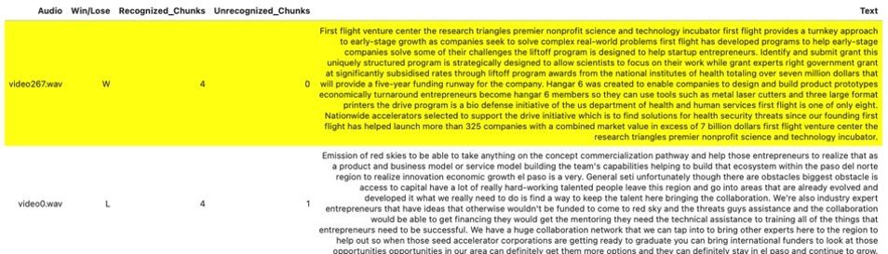

We have plotted the text plots of winners and losers videos to analyze the word density and how closely few words are being used. In case of winners, the concentration of words like Community, Entrepreneurs, Capital, Funding, Local and Startup were very commonly used whereas, in case of losers, words like Accelerator, Small, Food, Technology, etc. were used. Along with the text plots, to analyze deep, collocation analysis was performed. In this, it allows us to identify contiguous collocations of words. A dictionary of stop words were being used to ensure the most common words doesn’t mislead the overall text analysis.

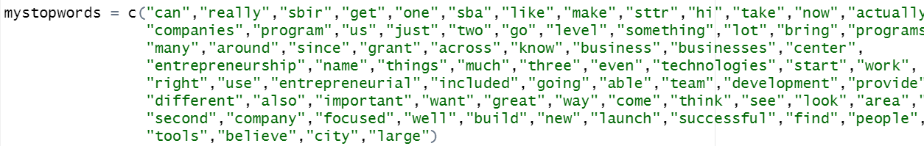

The text analysis was of prior importance in overall video analysis as it supports the video and audio analysis.

Collocation Analysis for Winners:

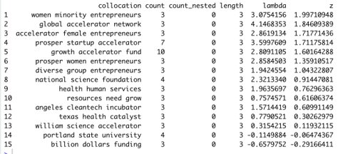

Collocation Analysis for Losers:

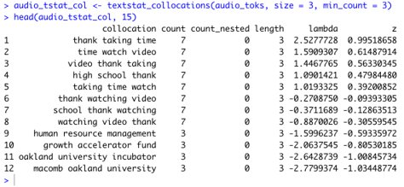

**CHALLENGES**

Every project comes with some challenges and so does this project too. Some of the challenges that are expected for the project are as follows

* Video Sourcing:
  + Finding losers videos: The SBA website has a set of videos from each year. However, these are the videos of only the winners of the Growth Accelerator Fund competition. The primary aim of the project being to find what defines the winners and distinguish them from the losers. It becomes a necessity to fetch the videos of the other participants too. Finding a set of key word lists that could extract all the videos of the participants and getting the relevant videos of the participants after feeding in the keywords will be challenging.
* Text analysis:
  + Conversion Validation: The are various formats of data conversion that is dealt at various stages. Every video will be converted to audio to extract the text. This would involve validation of data and quality at every step. As a part of a trial run for a few videos, it was found that the videos that are sourced do not take a uniform format. They differ between 3GPP or MP4 format. It was found that the accuracy of audio and text conversion of the videos were not perfect. This could lead to loss of information and misleading the analysis and findings of the project. Hence the data validation programmatically and to some extent manually could be involved which would be a cumbersome process.
* Time and complexity: The SBA website have about 40 to 60 videos of the winners every year since 2014. Each of these videos spans 2 mins each. The images would be taken for every frame and each video must be converted to audio to further process into text. This also involves data cleaning like removing the unclear images and removing stop words before any machine learning model can be applied. It becomes even more challenging when it must be done for the other participants' video. Additionally, the time taken to run the image processing, NLP and other Neural network models to detect the emotions for each of the videos and summarizing them would be challenging given the expected volume of videos and within the period that we are targeting for completion of the project.

**FUTURE WORK**

* The next step would be to combine 3 machine learning models integrated under a functional API Keras, which can do the analyses under the 3 models, i.e.,
  + Audio,
  + Video, and
  + Text. A video passed through this functional API will give an output considering 3 aspects of the video.
* We have faced an issue in doing text Detection solely from images. Any text overlapped with an image or graphic has shattered the text detection. This needs to be addressed.
* Optimizing frames: Current video analysis captures and analyses all the frames in a video. For Ex: A video is 2 min length, and we capture frames after every second. This video comprises 120 frames. Although all these 120 won’t be of much use. But, to build an optimized ML model, we need to capture only a few frames and remove the duplicates using a function. We will be using pyscene and pydetect functions.
* Electronic Music Data Analysis: Background music in all the videos will be analysed to understand the music used and its relevance.

**LEARNIGNS AND TAKEAWAYS:**

**Team Learnings:**

* Team Management: We were able to split the work among ourselves strategically and addressed the issue as the overall project was gigantic and difficult for any 1 or 2 person to handle the code aspect of the project.
* Dedication: I was able to learn how dedicated my teammates are for the project and that motivated me to do put more hours trying to finish the project as much as I can.
* Time Management: We have kept deadlines after our project proposal and divided the project into chunks. We were optimistic in dividing the project but got stuck in few aspects due to other reasons.
* Contribution: I personally feel that I should have had knowledge of video analysis in prior to contribute more to the team and overall project.

**Technical Learnings:**

* Video analysis was new to each one of us and using GCP, analyzing a frame was very interesting as I was intrigued by the number of features GCP Cloud Vision API has and the minute details it captures.
* We have used R and Jupyter Notebook extensively and I was able to come through many new libraries and their use cases.

**REFERENCES**

* OpenCV for Python: <https://www.geeksforgeeks.org/python-process-images-of-a-video-using-opencv/>
* Image and video processing in Python: <https://www.sciencedirect.com/science/article/pii/S2405844019362206>
* Using Google Cloud Video Intelligence and Cloud Vision APIs: <https://www.qwiklabs.com/focuses/1831?parent=catalog>
* Analyzing video using Python, OpenCV and NumPy: <https://medium.datadriveninvestor.com/analyzing-video-using-python-opencv-and-numpy-5471cab200c4>
* https://global.hitachi-solutions.com/blog/6-reasons-to-use-azure-databricks-today
* https://docs.aws.amazon.com/AmazonS3/latest/userguide/Welcome.html